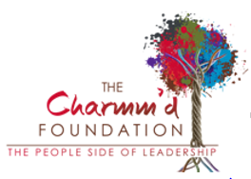
The Charmm’d Foundation is a private nonprofit organization that provides leadership development and training opportunities to leaders is looking for an Executive Assistant.

The Executive Assistant supports the 3 Directors and collaborates to make sure all runs as smoothly and efficiently as possible so the directors can focus their time doing what they do best. This individual is the team’s nucleus and helps keep the team running like a well-oiled machine. Key duties include: creating custom reports, coordinating meetings/events, maintaining a clean and up-to-date database, sending marketing emails, providing customer service and hospitality to both the internal and external customers, and conducting general office tasks as required.

This position requires a, highly organized individual with an expert skill set who can manage multiple priorities while possessing excellent written, verbal, grammatical and interpersonal skills. This person must be detail-oriented, possess excellent people skills and enjoys having a steady stream of tasks to accomplish while supporting a high-functioning, motivated and busy team of professionals.

For more information visit: https://www.charmmdfoundation.org/. For a complete job description or to submit your resume, please contact us at HRDept@benida.com.

